**Fall Semester 2021-22**

**SCHOOL OF COMPUTER SCIENCE AND ENGINEERING**



**PROJECT REPORT**

**By:**

**Rushil Goel (19BCE0361)**

**Sanskrita Saha (19BCB0059)**

**Nikunj Choudhary (19BCE2335)**

**Sreekar Chowdhary (19BCE2348)**

**Submitted to**

**Prof. RAJAMURUGAN G**

**Course Code: MGT1022**

**Course Name: Lean Start-up Management**

**TE-1 Slot**

**VISION**

* To provide our customers with finest quality products paying utmost attention to customer satisfaction.
* To be recognised a successful brand and market leader in finest and high-quality handicraft sector.
* To offer complete support to every level of handicraft industry. Including people engaged in gathering raw materials and handicraft artisans themselves.
* To help in protection, saving and development of small-scale artisans and their skills in order to preserve that as an integral part of our culture.
* To offer our customers premium functional artwares, table-wares, home-wares, gift-wares, and Indian handicraft and decors and be recognised as a customer and market driven which strives for customer satisfaction, quality products, reliability, performance and excellence.
* -To generate employment for people in the field of handicrafts like artisans and transporters and etc.

**MISSION**

* Boost productivity by updating technology and tailoring products to market needs.
* Empower craftsmen to earn long-term earnings and thereby combat poverty. Our artisan groups come from all over the country and have a wide range of ethnic backgrounds.
* To enable underprivileged communities to use their craft and craftsmen talents as a sustainable source of income.
* Women's Empowerment: We think our women must be financially self-sufficient. We have increased the enthusiasm and participation of craftsmen in their work by giving their craft the respect and genuine value it deserves.
* -Increase awareness of handicrafts and craftsmen' reliance on them by conserving India's rich tradition and culture.
* Develop a platform that allows craftsmen from all across India to sell internationally, allowing buyers to locate and learn about Indian handicrafts that they might like to purchase online.
* To make the produce of Indian handicrafts by small scale industries more accessible to the common public and make Indian handicraft more popular in international markets.

**SHORT TIME GOAL OF THE COMPANY**

Short-term planning examines the company's current features and sets plans to improve them. Employee skills and attitudes are two such examples. Also taking into account the state of the production equipment or the quality of the finished product. We implement short-term remedies to these challenges in order to address them. Short-term remedies include employee training, equipment maintenance, and quality improvements. These answers pave the way for a more comprehensive approach to challenges in the future. As a customer centric and market driven company, we strive to serve our customers the finest quality products and make sure that all our customers are satisfied with our service. We plan on developing both a mobile app for android and iOS as well as a website to make ourselves more reachable. We also plan to use social media to publicize our products well. We can use social media handles like on Facebook, Instagram and Twitter. With the funding we receive, we would use a part of it for promotions and marketing. We would also reach out to artisans asking them if they are willing to sell their handicraft to us so that we can deliver it to a wider public and offer them a steady pay. We would gradually put-up products on our website and apps and ask for the review from initial customers to make any required changes. We would encourage women artisans and even train them so that they can be self sufficient financially. We plan on conserving artisan’s skills and also revive skills that we thought we have lost. We would train artisans and also make them aware about what people actually need in the market. For example, during pandemic times, everyone needs a face mask. We would make artisans aware about the increasing demand of face masks in the market and would try to cater it with our high-quality products. We believe in word of mouth and would let our fine products speak for us.

Setting up a company requires configuring everything from supply to logistics and demand in market as well as customer satisfaction. We would try to reach out to shops in metro cities that can cater the need of people living there. Thereby, we would be making ourselves accessible to people via both online and offline modes. With dedicated shops selling our products, we would be able to reach more people and at the same time people who are afraid of online shopping can also access our premium crafted products without any hesitation.

**COMPANY NAME**

* A company name should convey what the company does.
* It should reflect the product and who it is targeted towards as well.
* It should be something that sticks to people’s minds and something that’s easy to remember as well.
* It should not be difficult to pronounce.
* As we want to host our website as well, we should check with available domains as well.
* It should be a simple name, better if it’s taken from a word that people use commonly so that people don’t find it difficult to use.
* Check grammar of name and tag line.
* It should not be offensive.
* It should not include words that indicate a separate business or legal person like co-operative, trust, or society.
* Do not use abbreviations, adjectives and generic words.
* If the proposed name is the exact translation of an existing reputed company name in English that will not be allowed.

**LOGO**

* Consider how you want to utilise your logo today and, in the future, when choosing a design.
* Consider your company's beliefs as well as your customer/client profile when selecting an image style.
* It should be distinct and unique in its own way.
* Choose colours that you know you'll like today and after 20 years.
* It should be appealing.
* Should depict company values and product.
* Should be iconic and should stick to customer’s mind.

**TAG LINE**

* The tag line should be kept short in length.
* The tag line should be kept very simple.
* The logo and tagline should communicate precisely a story. The story of the brand.
* The tag line should be simple, memorable and functional.
* The message that we want to deliver by the company name and tag line should be communicated very clearly.
* Not every tag line needs alliteration, a clever rhyme, or a pun.
* Tagline should deliver the company’s mission, vision and values to the customers.
* As the market is very dynamic, the tag line should be sustainable to survive the ever-changing market and consistently deliver the company’s morals to the customers and stick with them.
* There should be no hint of mystery in the slogan. Customers should be able to learn everything they need to know about the company from the tagline alone.

**Proposed logo –**

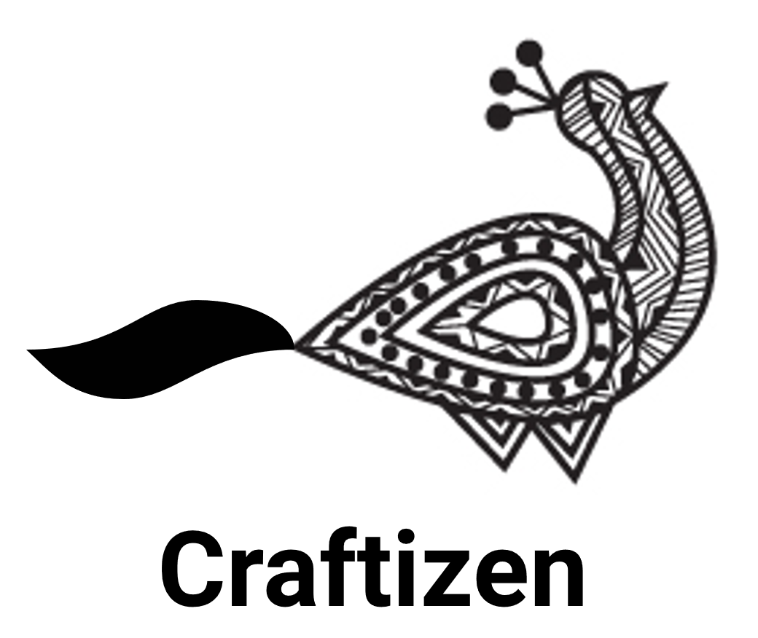

I propose the name of our company to be - **Craftizen.**

**Proposed tag line –**

**“For The Handmade Joy of Living.”**

**TYPE OF BUSINESS**

As we are just starting our business, we are a micro company but we plan on turning ourselves into a macro company in coming years. We want to implement our idea on a large scale. We want to generate employment for more artisans, from every corner of India. We want to help in preserving tribal art of communities in eastern India to skilled weavers of western India. We are expecting a very reasonable turnover in coming years. We plan on starting with 0.5 crores in the base year and subsequent revenue to increase as much as twice the base year revenue. We also expect our growth to be as of any other big enterprise. We expect a triple digit growth in first few years which would come down after around 4-5 years. Our expectations in case of revenue and growth are very practical and we believe that we can achieve the same. We also aim at providing maximum customer satisfaction. While big enterprises have around 50% customer satisfaction, we aim at around 75% because we understand our customer’s anticipation around buying handicrafts online and thus want to attend to almost every inquiry we get.

We realise the goal we are setting for ourselves are in no way small but we want to establish our company and we aim at becoming the market leaders in premium handicraft segment. We plan on launching both mobile app and website so that we can reach a wider audience. We want to cater our customers regardless of the device they use. We plan on making iOS, android as well as a responsive website so that no customer feels that that cant accesses our services. We realise that managing so many codebases and applications will be difficult but we want to sustain in the market and lead it and hence its very necessary to make ourselves as much accessible as we can.

We want to implement policies and procedures that shape the company's profile

to match top management's ideas. We plan to increase our reach to other people. We plan on doing so by means of television advertisements, social media and hoardings on billboards. We would also look into opportunities of collaborating with other enterprises. We can collaborate with companies like Myntra for products like apparel and clothes. We can supply them products made by artisans which would be incorporated into dresses by Myntra and sold off to customers. This would enable us a wider publicity as well as a platform to reach more people and serve them with premium handicraft products. We might incorporate small businesses into our company if we believe in it or we can also ask small business individuals if they want to work with us. We do not plan on forming a coalition with any other company as of now, but if we think its necessary for the company and is the right opportunity, we would be open to the idea.

Starting off as a start-up who wishes to sustain in the market and is ambitious enough to dream of becoming the market leader is difficult but we wish to stand up against all odds. We are starting out as a micro company but we aspire to transform into a macro business very soon.

**PRODUCT AND SERVICES**

We often hear about how small-scale artisans are forced to leave their businesses as they are not able to earn enough to keep the business going. At the same time, we also see how big ecommerce platforms don’t promote handicrafts and even the products that are available online have very low rating. It’s also important to note that the handicrafts that are available online are mass-produced and is killing the small-scale industry of artisans who are skilled in making these handicrafts. Even people who purchase handicrafts from these ecommerce websites, they are not completely satisfied with the product further decreasing the product ratings. Thus, to serve the customers with handicraft products that come straight from artisans and are not mass produced, delivered to them at their doorstep with ensured customer satisfaction, we decided to develop this platform dedicated to the sale of handicrafts.

Our company has a vision to cater our customers with the finest handicraft products while preserving small scale artisans and their craft and generating employment for them. We want more women to join us so that we can make more women self-sufficient and self-reliant.

* Our products will be sold at very competitive prices and thus will be accessible to more people. We understand that people would be okay spending money on articles they think are worth it, thus we will keep our product prices accordingly so that it is profitable for artisans as well as affordable for customers.
* We understand that many customers have a specific need when it comes to handicrafts which might not be available by the mass-produced handicrafts that are offered on big e-commerce websites. Hence, we plan on adding a feature to our application that will help users to add specific details of the product they want us to make for them. We believe that this will help the users to get products tailored to their needs and will help us deliver the finest customer first experience.
* We understand that a friendly user experience is not just delivered by our products but also our platforms. Thus, we will build very user-friendly applications for payments as well as shipping process where we will be identifying our customers, asking them for shipping address and special requests like gift wrapping or adding a note to their parcel, asking them to select a payment method, show them an overview of the order including the price breakdown, asking them for a confirmation to place order and finally send a confirmation of the order after placing the order via an email. The customer can choose to abort the checkout anytime and also add the product to a wish list for future considerations.
* It is very common to come across reviews on big e-commerce platforms talking about how the shipping was compromised and damaged products were received by the customers. We would try to take action on each complaint we receive. We would try to eliminate issues faced by our customers. One way of ensuring this is collaborating with established and big shipping partners like FedEx, Blue dart and DHL.
* We believe in economical as well as eco-friendly products and thus we will try to avoid and minimize the use of artificial products like plastic etc in our products and replace it with natural supplies so that they are less toxic and harmful for environment while continue being user friendly.
* Most handicrafts are vividly and brightly coloured and mass-produced handicrafts which uses harmful dyes which degrade the environment on disposal. We believe in using natural dyes and colours that would look much attractive on the products and will not harm the environment. We would able to save up the cost by taking this step as well hence reducing the production cost and making the handicrafts available at a much cheaper price.

**MARKET ANALYSIS**

* First, its essential to figure out our target customers. We believe that our customers would be a variety of mixed ethnic backgrounds and of varied ages and gender. Anyone with a thing for Indian décor and a thing for handmade products would be willing to spend their money on our products. We believe that our customers can be traditional people, devotional and religious people, natural product lovers, woven dress enthusiasts, gift shops, fancy stores, emporiums, fashionists, stylists, interior designers and people from different age groups like teenagers, adults and even senior citizens.
* The market we are targeting is huge. India being our target market has surplus opportunities and people who would be interested.
* The profit we make by selling off our products will be more than enough to keep the marketing going as well as enough to sustain the artisans.
* We realise that most big established enterprises are platforms that sell variety of products to their customers. They don’t sell just one segment products while we would be targeting only handicrafts. We believe that because we are focusing on just one category, we would be able to deliver more customer satisfaction compared to these big companies.
* There is a competitive rivalry that exists in the market. The trend of extinction of small retailers through acquisitions, mergers, alliances and high cost to exist this market is common.
* As no company is solely targeting handicraft segment, the competition we will face would be less. We are new to this business so we don’t have any brand in this fields like Amazon or Flipkart. So initially customers will be less. In this time, we may lose some sellers.
* Online stores are more accessible than offline roadside stores. Marketing, record keeping, managing etc becomes easy as well.
* Many people prefer mobile app for making purchases and we have a mobile application is place specifically for this.

**TECHNICAL FEASIBILITY**

Our product is technically feasible and would attract a lot of people. We have made a design of the user interface for both the website as well as mobile application. We will have a team of technicians at all times to help us in case we run into any problem. They would keep updating the online store with new offers and schemes so that we can attract more people. We would also launch a prototype and get feedback over it to perfect our platform. Technical support includes the admin of the software. A team of software engineers need to look after the technical functioning of the business. The success of this online virtual store lies entirely in the hands of the technical team. The other partner includes the inventory clerk who is responsible for managing incoming and outgoing supplies and products within a business. It may involve the task of maintaining the raw supplies and ordering new supplies The admin maintains the record about the customer’s details, the stock details, the supplier details, the delivery person details. The mobile application will be made in flutter which would enable us to make an application for both android as well as iOS mobiles. We plan on using ReactJS for the website which makes the user interface very attractive and is very fast when put into production. We plan on leveraging attractive website to attract more customers and paying emphasis on user experience.

**SCREENSHOTS**

**Link -** https://www.figma.com/proto/Cgi1ONfVWV7jEL0HBtIYie/glassmorphism?node-id=155%3A3

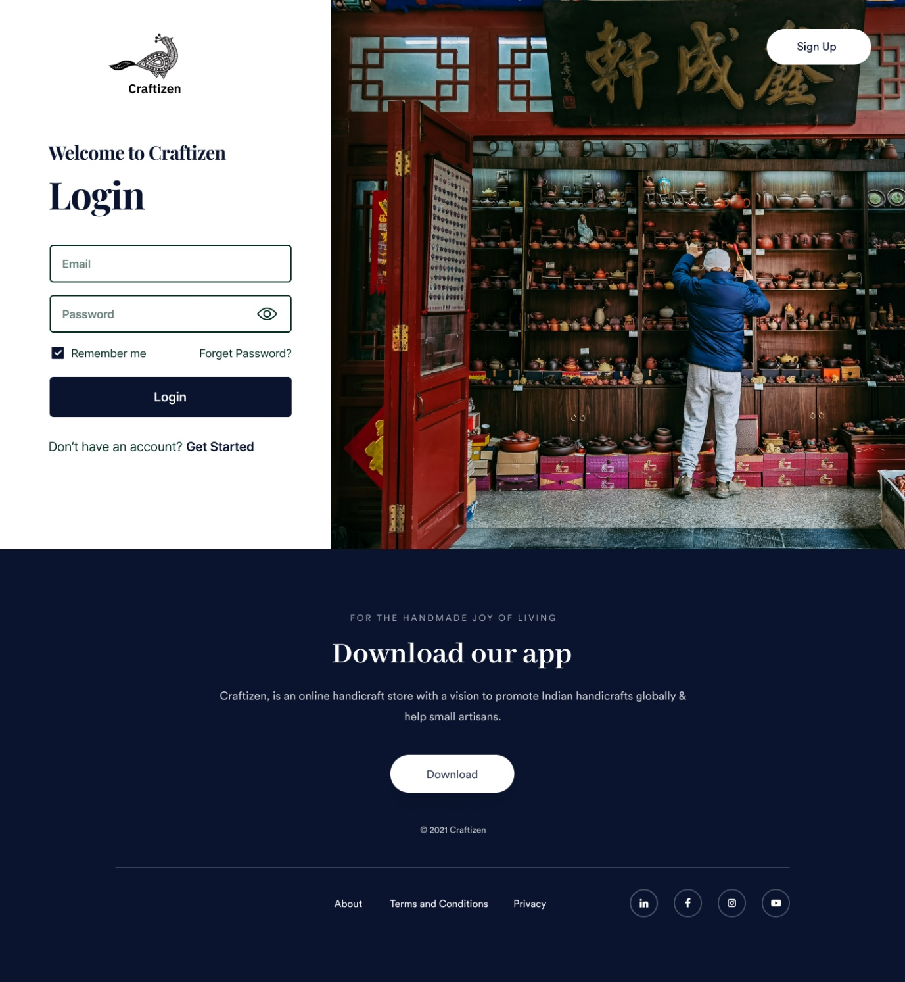

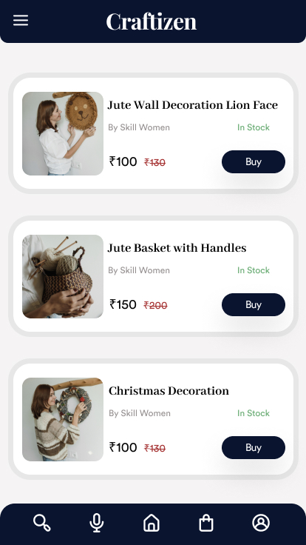

**CSS Code Snippet**

* {

box-sizing: border-box;

}

body {

font-size: 14px;

}

.v159_2 {

width: 100%;

height: 1561px;

background: rgba(255,255,255,1);

opacity: 1;

position: absolute;

top: 0px;

left: 0px;

overflow: hidden;

}

.v164_69 {

width: 153px;

height: 106px;

background: url("../images/v164_69.png");

background-repeat: no-repeat;

background-position: center center;

background-size: cover;

opacity: 1;

position: absolute;

top: 40px;

left: 173px;

overflow: hidden;

}

.v155_5 {

width: 150px;

height: 100px;

background: url("../images/v155_5.svg");

background-repeat: no-repeat;

background-position: center center;

background-size: cover;

opacity: 1;

position: absolute;

top: 0px;

left: 3px;

}

**HTML Code Snippet**

<!DOCTYPE html>

<html>

<head>

<link href="https://fonts.googleapis.com/css?family=IBM+Plex+Sans&display=swap" rel="stylesheet" />

<link href="https://fonts.googleapis.com/css?family=Circular+Std&display=swap" rel="stylesheet" />

<link href="https://fonts.googleapis.com/css?family=Abhaya+Libre&display=swap" rel="stylesheet" />

<link href="https://fonts.googleapis.com/css?family=Inter&display=swap" rel="stylesheet" />

<link href="https://fonts.googleapis.com/css?family=Playfair+Display&display=swap" rel="stylesheet" />

<link href="./css/main.css" rel="stylesheet" />

<title>Craftizen</title>

</head>

<body>

<div class="v159_2">

<div class="v166_46"></div>

<div class="v164_69">

<div class="v155_5"></div>

<div class="v155_7"></div>

<div class="v158_2"></div>

<div class="v158_3"></div>

<div class="v155_8"></div><span class="v155_10">Craftizen</span>

<div class="v158_4"></div>

<div class="v158_22"></div>

<div class="v158_23"></div>

<div class="v158_24"></div>

<div class="v158_12"></div>

<div class="v158_13"></div>

<div class="v158_14"></div>

<div class="v158_15"></div>

<div class="v158_16"></div>

<div class="v158_17"></div>

<div class="v158_18"></div>

<div class="v158_5"></div>

<div class="v158_6"></div>

<div class="v158_7"></div>

<div class="v158_9"></div>

<div class="v158_10"></div>

<div class="v158_11"></div>

<div class="v158_19"></div>

<div class="v158_20"></div>

<div class="v158_21"></div>

</div>

<div class="v159_9"></div><span class="v163_18">Sign Up</span>

<div class="v163_22">

<div class="v163_23"></div>

<div class="v163_24"><span class="v163_25">© 2021 Craftizen</span><span class="v163_26">Download our app</span><span class="v163_27">For the handmade joy of living</span><span class="v163_28">Craftizen, is an online handicraft store with a vision to promote Indian handicrafts globally & help small artisans.</span>

<div class="v163_29">

<div class="v163_30"></div>

</div><span class="v164_97">Download</span>

<div class="v163_32"></div>

<div class="v163_33"><span class="v163_34">About</span><span class="v163_35">Terms and Conditions</span><span class="v163_36">Privacy</span></div>

<div class="v163_37">

<div class="v163_38">

<div class="v163_39">

<div class="v163_40"></div>

<div class="v163_41"></div>

</div>

</div>

<div class="v163_42">

<div class="v163_43">

<div class="v163_44"></div>

</div>

<div class="v163_45">

<div class="name"></div>

</div>

</div>

<div class="v163_49">

<div class="v163_50">

<div class="v163_51"></div>

<div class="v163_52">

<div class="v163_53"></div>

<div class="name"></div>

<div class="name"></div>

</div>

</div>

</div>

<div class="v163_60">

<div class="v163_61"></div>

<div class="v163_62">

<div class="v163_63">

<div class="v163_64"></div>

<div class="v163_65"></div>

<div class="v163_66"></div>

</div>

</div>

</div>

</div>

</div>

</div>

<div class="v164_99">

<div class="name"></div>

</div><span class="v164_107">Password</span>

<div class="v164_108"><span class="v164_109">Don’t have an account?</span><span class="v164_110">Get Started</span></div><span class="v164_111">Email</span><span class="v164_112">Login</span><span class="v164_113">Welcome to Craftizen</span>

<div class="v164_114"></div>

<div class="v164_115"></div>

<div class="v164_116">

<div class="v164_117"></div><span class="v164_118">Login</span></div><span class="v164_119">Forget Password?</span><span class="v164_120">Remember me</span>

<div class="v164_121">

<div class="v164_122"></div>

<div class="v164_123"></div>

</div>

</div>

<div class="v159_2">

<div class="v166_46"></div>

<div class="v164_69">

<div class="v155_5"></div>

<div class="v155_7"></div>

<div class="v158_2"></div>

<div class="v158_3"></div>

<div class="v155_8"></div><span class="v155_10"></span>

<div class="v158_4"></div>

<div class="v158_22"></div>

<div class="v158_23"></div>

<div class="v158_24"></div>

<div class="v158_12"></div>

<div class="v158_13"></div>

<div class="v158_14"></div>

<div class="v158_15"></div>

<div class="v158_16"></div>

<div class="v158_17"></div>

<div class="v158_18"></div>

<div class="v158_5"></div>

<div class="v158_6"></div>

<div class="v158_7"></div>

<div class="v158_9"></div>

<div class="v158_10"></div>

<div class="v158_11"></div>

<div class="v158_19"></div>

<div class="v158_20"></div>

<div class="v158_21"></div>

</div>

<div class="v159_9"></div><span class="v163_18">Sign Up</span>

<div class="v163_22">

<div class="v163_23"></div>

<div class="v163_24"><span class="v163_25">© 2021 Craftizen</span><span class="v163_26">Download our app</span><span class="v163_27">For the handmade joy of living</span><span class="v163_28">Craftizen, is an online handicraft store with a vision to promote Indian handicrafts globally & help small artisans.</span>

<div class="v163_29">

<div class="v163_30"></div>

</div><span class="v164_97">Download</span>

<div class="v163_32"></div>

<div class="v163_33"><span class="v163_34">About</span><span class="v163_35">Terms and Conditions</span><span class="v163_36">Privacy</span></div>

<div class="v163_37">

<div class="v163_38">

<div class="v163_39">

<div class="v163_40"></div>

<div class="v163_41"></div>

</div>

</div>

<div class="v163_42">

<div class="v163_43">

<div class="v163_44"></div>

</div>

<div class="v163_45">

<div class="name"></div>

</div>

</div>

<div class="v163_49">

<div class="v163_50">

<div class="v163_51"></div>

<div class="v163_52">

<div class="v163_53"></div>

<div class="name"></div>

<div class="name"></div>

</div>

</div>

</div>

<div class="v163_60">

<div class="v163_61"></div>

<div class="v163_62">

<div class="v163_63">

<div class="v163_64"></div>

<div class="v163_65"></div>

<div class="v163_66"></div>

</div>

</div>

</div>

</div>

</div>

</div>

<div class="v164_99">

<div class="name"></div>

</div><span class="v164_107">Password</span>

<div class="v164_108"><span class="v164_109">Don’t have an account?</span><span class="v164_110">Get Started</span></div><span class="v164_111">Email</span><span class="v164_112">Login</span><span class="v164_113">Welcome to Craftizen</span>

<div class="v164_114"></div>

<div class="v164_115"></div>

<div class="v164_116">

<div class="v164_117"></div><span class="v164_118">Login</span></div><span class="v164_119">Forget Password?</span><span class="v164_120">Remember me</span>

<div class="v164_121">

<div class="v164_122"></div>

<div class="v164_123"></div>

</div>

</div>

</body>

</html>

**COMPANY POLICIES**

Our company enforces various policies to safeguard interests of our customers, fellow artisans and staff, some of them are:

* Our company has a complete replacement/refund policy against manufacturing defects and delivery damages.
* We allow our fellow artisans to take some time off from work if they want to learn a new craft. The tutors for the same will be provided by the company and we will be paying the artisans some stipend even when they are no working and learning the new craft. We do this so that artisans can learn more crafts and skill up. It will enable them to earn more at the same time will help the company to get artisans skilled in various crafts.
* We realise that a majority of our employees will be females, hence whenever needed, they can take a 3-month paid maternity leave which is extendable in special cases.
* We also enforce an equal opportunity policy (EOP) which prevents us from discriminating against job applicants or employees if they are a member of a protected class (e.g, race, gender, age, religion, familial status, colour). The EOP is essential for any anti-harassment, workplace violence, non-discrimination.
* We attend to our customers grievances very seriously as customer satisfaction is one of our key mottos. Hence, we have a 24x7 customer service available for assisting our customers and parallelly they can also reach out to us via emails and WhatsApp chat feature.
* For various reasons ranging from health issues to vacation plans, employees may occasionally require to be absent from work. Different kinds of leave (sick leave, Paid Time Off, maternity leave, parental leave etc.) are separate entities and may require different treatment.
* We believe that as a handicrafts company, we will come up with many interesting ideas and would like to work on them with our team. Thus, we would enforce a use of social media policy which outlines what employees may and may not share online and which rules apply to the use of the company’s own IT infrastructure. With that in place, employees are free to use out IT infrastructure for skilling up, accessing resources and training.

**TIN NUMBER**

Our Company would have to apply for a valid business TIN. As we purchase and deliver handicrafts to our customers, it is mandatory for us to have a TIN. TIN is an identification number assigned to business enterprises for tracking their transactions. TIN is basically required for all entities that are registered under VAT for trade of goods and services. TIN consists of 11 characters out of which the last two depict the state of the applicant. If I was applying for TIN number for our company, the first 2-digits of it would be 10 and state code would be BH as I would be applying from Bihar. An online form can be filled for the same and relevant documents can be uploaded. We would need, identity proofs, address proof, proof of address of business, PAN card and security.

**VAT**

Our company will also have to apply for VAT. Application needs to be submitted and relevant documents are supposed to be submitted. Local VAT office will inspect our business and charge a fee. After this, TIN will be allotted to us. VAT fees is about Rs 500 and depending on the turnover, it is charged. It depends from state to state and city to city. For applying online, we need to Log on to our state’s VAT website and click on the registration tab. Then we need to add information and attach documents as request for our company and we will be allocated our temporary VAT registration number. Once the verification is complete, our Permanent VAT registration number is allotted and we can check the status online. We will have to submit various documents like,

* Incorporation Certificate of Company (in case of Companies)
* MoA & AoA (in case of Companies)
* Particulars of people involved in the firm.
* Address Proof of Director – Lease / Rental Agreement
* Company PAN Card / Individual PAN card in case of Proprietorship
* ID Proof of Director – Pan Card / [Election Card](https://www.bankbazaar.com/voter-id.html)/ Passport/ Driving License
* Rental Agreement/ Lease Agreement of Company / Proprietorship
* In case of Partnership firm- Partnership Deed
* Passport size Photograph of Director of the firm

Since, TIN mandatorily needs to be quoted while submitting VAT, hence, the Tax Identification Number is furnished automatically at the time of registration. TIN is used to identify businesses registered under VAT. This is an effective way to track transactions carried out by enterprises in the country.

WIN tax would not be applicable for our company as our company does not deal with that.

**GSTIN**

Our company will have to apply for GSTIN. We can apply for this online and the process is fairly straightforward. GSTIN has replaced all other taxes and thus this single form of tax is enough or our company. Thus, applying for GSTIN is very important. Our category would be normal taxpayer as our business is not seasonal and would be active all year long. We are also residents of India and hence our business falls under this category. Failing in registering for GSTIN, we will have to pay heavy penalties. For applying for GSTIN, we would need

* [PAN](https://cleartax.in/s/pan-card) of the Applicant
* [Aadhaar card](https://cleartax.in/s/aadhaar-card)
* Proof of business registration or Incorporation certificate
* Identity and Address proof of Promoters/Director with Photographs
* Address proof of the place of business
* Bank Account statement/Cancelled cheque
* [Digital Signature](https://cleartax.in/s/digital-signature-certificate-get-dsc)
* Letter of Authorization/Board Resolution for Authorized Signatory

We need to register at <https://reg.gst.gov.in/registration/> and submit the needful.

**TOTAL NUMBER OF EMPLOYEES**

In total, our company will have about 30 employees to start with. We will be hiring more employees as we grow and will expand our business.

To provide authentic online store assistant for each store -

* An admin to maintain the record about the customer’s details, the stock details, the supplier details, the delivery person details.

For maintaining raw supplies and order new supplies -

* An inventory clerk who is responsible for managing incoming and outgoing supplies and products within a business. It may involve the task of maintaining the raw supplies and ordering new supplies.

Technical support staff

* A team of software engineers need to look after the technical functioning of the business. The success of this online virtual store lies entirely in the hands of the technical team.

Logistic Services

* Consumers demand better service, and this mandate creates a need for shippers to provide fast, accurate and quality service. Good management strategy is aimed to constantly optimize transportation processes and eliminate disruptions. Therefore, it has a direct impact on customers’ satisfaction.
* Improved customer service can bring a good reputation to a company’s brand and help generate more business. Ultimately, well-handled logistics contributes to the overall positive customer’s experience.

Team of Tutors

* As a company, we would always encourage our fellow artisans to skill up by learning new crafts. Hence, we assembled a team of tutors to help them in learning a craft and helping them skill up.

Human Resources

* To overlook the working in the company and taking care of employee grievances.

Customer Support

* To manage customer grievances.

We also believe that as a growing start-up, we will have a lot of opportunities for students to learn and grow. Thus, we would be open to the idea of hiring interns in various technical and non-technical domains. We would hire them by either visiting few universities or even off campus recruitments. We believe in appreciating the hard work interns will put in and thus will make sure that all our internships are paid and that our interns get to learn a lot from the work our company offers them.

**COMPANY CHART**

**COMPANY REGISTERATION**

We believe that Private Limited Company structure is well suited for our company. We believe so because, Our business has two or more owners and is actively seeking investment from other parties. We are also sure that we will be able to recover the setup and compliance costs. Its also better because of limited liability clause. This means that the liability of its members is restricted to the amount of contribution made by them or the value of shares each member holds. Choosing a Private limited structure will also help us in attracting investors because of the trusted structure. This structure will also help with our high turnover.

We must submit an application to the Ministry of Corporate Affairs (MCA). We make the application online at MCA portal remotely too. For registration, we’ll need a Digital Signature Certificate (DSC), and Director Identity Number(DIN), among other things.

To register a company in India, We need-

* 1. Digital Signature certificate.

As the registration process of the company is completely online, Digital signatures are required to file the forms on the MCA portal. DSC is mandatory for all the proposed directors and the subscribers of the memorandum and articles of association.

* 1. Director Identification Number (DIN)

The Director Identification Number (DIN) is an identification number for a director and it has to be obtained by anyone who wants to be a director in a company. The DIN of the proposed director along with the name and the address proof is to be provided in the company registration form.

* 1. Registration on the MCA Portal

To apply for company registration, the SPICe+ form is to be filled and submitted on the MCA portal. To fill the SPICe+ form and submit documents, the Director of the company has to register on the MCA portal. After registration, the director can log in and will obtain access to the MCA portal services which include filing e-forms and viewing public documents.

* 1. Certificate of Incorporation

Once, the registration application is filled and submitted along with the required documents, the Registrar of Companies will examine the application. Upon verification of the application, he will issue the Certificate of Incorporation of the Company.

**SUBSIDIES**

In India, registration of a company cannot be done without proper proof of identity and proof of address. Proof of identification and address would be required for the incorporation of all the company’s directors and shareholders. All the particulars of the directors and shareholders is to be submitted to the registrar at the time of registration. Pan Card/Aadhar card/Diving license/passport can be submitted as proof of identity. Latest Telephone Bill /Electricity Bill/ Bank Account Statement is to be submitted for proof of address.

The organisation must have a registered office in India for online business registration in India. A recent copy of an energy bill or the property tax receipt or water bill must be sent to confirm admission to the registered office. In addition to the tenancy/rental agreement, the maintenance bill or the sale deed or a letter or NOC from the landlord with his/her permission to use the office as the company’s registered office is accepted. Along with these documents the DIN and DSC of all the directors is also to be submitted. These documents mentioned are the general documents which are to be submitted for registration of LLP, One Person Company, Private Limited and Public Limited Company.

Our company can leverage various government subsidies that are open for public like the A. Ambedkar Hastshilp Vikas Yojana, Handicrafts Artisans Comprehensive Welfare Scheme, Infrastructure and Technology Development

Scheme. According to these schemes, we can help our fellow artisans receive a much better infrastructure.

Government of India organizes Mega clusters is a drive to scale up the infrastructural and production chain at Handicrafts clusters which have remained unorganized and have not kept pace with the modernization and development that have been taking place so far. The Mega Clusters will be taken up for development through Handicrafts Mega Cluster Mission (HMCM) or through Central/State Corporations as and when announced in Union Budget or as per requirement and as per the DPR prepared for the purpose. The objective is to develop these clusters with world-class infrastructure. The guiding principle behind the design of clusters would be to create world-class infrastructure that caters to the business needs of the local artisans & SMEs to boost production and export. We will encourage our fellow artisans to attend such clusters so that they can promote their craft and at the same time understand the developing industry better. They will get exposure to various crafts which they can choose to learn later on.

According to A. Ambedkar Hastshilp Vikas Yojana,

• Financial Assistance will be provided to the tune of INR 300/- per artisan for the number of persons to be surveyed and mobilized for empowerment in the form of grant in aid.

• Financial assistance will be provided for a maximum of Rs 1 lakh per year for a maximum of three years for formation of Producer Company/ Federation/Institution.

Such grants can really help our fellow artisans financially and boost their morale. We always encourage them to attend as many meets and clusters as they can so they can understand how they can match the everchanging fast-paced handicraft industry.

Indian government also offers support in terms of marketing and services,

In order to promote and Market Handicrafts financial assistance will be provided to different eligible organizations to organize Craft Exhibitions in metropolitan cities/state capitals / places of tourist or commercial interest/ other places. This will provide direct marketing platform to the handicrafts artisans/SHGs/entrepreneurs from various parts of the country.

In order to promote and Market Handicrafts financial assistance will be provided to different eligible organizations to organize Gandhi Shilp Bazaars (GSB)/Crafts Bazar in metropolitan cities/state capitals / places of tourist or commercial interest/ other places. This will provide direct marketing platform to the handicrafts artisans/SHGs/entrepreneurs from various parts of the country.

The Indian government also takes care of research and development in this field. They allocate funds for the purpose to those who are eligible and willing to contribute to the development. This includes, development of infrastructure, geographical mapping of handicrafts, resource management etc.

According to these schemes, Artisans have a lot of opportunities to skill up and receive financial grants. We as a company are always in support of this and would always encourage our fellow artisans to apply for such schemes and attend meets and clusters.

**TOTAL COST ANALYSIS**

Cost analysis for our start-up would be an overview of different expenses that apply for our business like, legal fees, market research fees, insurance, taxes, utilities, rent, software, supply and logistics, website and domain, salaries of employees etc.

Incorporation fees of about Rs 20,000 will be allotted for filing articles of incorporation, for incorporating businesses, for licences and permits and registrations like TIN number and GSTIN. In many cases, like registering for GST, registering is free but the documents needed for the registration process require paying some charge. We believe that all such charges would be covered under Rs 20,000 as basic documents like Aadhar cards and PAN cards are already available with us.

Office space would be acquired on rent. We plan on opening an office in Chandigarh which will be around 1100 square feet office. According to our research, the rent would be around Rs 40,000 per month and would give up enough area to setup our office and start with our business. We do look forward to expand our business and that would mean bigger office space as well in future but for our initial setup, we think that we don’t need a huge office as we have limited employees and we want to keep our cost of business low.

(Link to property - <https://www.99acres.com/ready-to-move-office-space-for-rent-lease-in-industrial-area-phase-2-chandigarh-1100-sq-ft-spid-Y56542488>)

Inventory is another essential part of cost analysis. We don’t want to have a large inventory because that can lead to damage or spoilage of goods, we also don’t want a limited inventory because that would mean that our customers will have to wait much longer to get their products. As per initial investment, we believe that about Rs 15,000 would be enough for storage and inventory. Needless to say, we will have to expand it in the future as the business soars.

Marketing is the next part of cost analysis. We would not invest much in marketing initially as we plan on leveraging social media to promote our company. We will be investing in marketing using hoarding and TV commercials in the future but for the initial phase, we would allocate around Rs 5,000 for marketing that too for business cards etc. As for the promotions, we would use social media platforms like Instagram and Facebook and advertise our website to generate traffic. We plan on expanding ourselves as a small business initially and later on emphasise on paid advertisements and commercials and videos and giveaways.

Website and domain are very essential to make our company look professional, and to make it easy for our customers to navigate and display information about our services, products and contact information. While hosting and buying a domain name is cheap (around Rs 500 per year), additional cost of database storages and licences would bump up the total investment to about Rs 4000 per year. This includes database cost, hosting charges and server space cost. As the website traffic will increase with time thus a scalable server space will be a better investment. Our team is very capable of building the website from scratch and hence we have not included cost of hiring a professional to build our website.

Utilities like electric, gas, water, internet, and phone bills for our office space might come up as unseen expenses and hence we included them in out cost analysis. We expect it to be around Rs 10,000 for our mentioned office space. The allotted budget is a bit low but the property we are looking forward to is a furnished one and hence would not require as much investment.

Payroll is one of the major parts of our cost analysis and includes salaries of employees. We plan on paying our employees based on their profile, our marketing team would be paid around Rs 19,000 per month, technical team around Rs 22,000 per month, HR team around 23,000 per month, operations team around 20,000 per month and finance team around 21,000 per month. We realise our salaries are not the best in the industry but at the same time we would be giving additional options to our employees like bonuses, overtime and paid time offs.

Insurance is of various types but as per our research we believe that investing about Rs 40,000 per year for insurance will cover most of it. It will be covering general liability, business owner’s policies, professional liabilities, workers compensation and commercial umbrella. We think that all this can be covered under Rs 40,000 per year which obviously will be increased in subsequent years as our investment increases. There are variety of insurance providers like Bajaj Allianz and Bharati AXA, and online places like policy bazar to compare prices.

Shipping will take another chunk with rates around Rs 15 per 0.5 Kg of goods. Companies like shiprocket and shipyaatri provide us with reliable delivery partners and economical prices.

Apart from this we would allocate funds for miscellaneous and unseen expenses. We also plan on hiring interns and paying them on monthly basis. Thus total cost estimate would be around 2 lakhs. Many expenses would be one time expense like registering the company and legal formalities.

**PRODUCTION COST**

Production cost for our products would be very low as the materials we will be using for making handicrafts would mostly be unprocessed. It would mostly be dry straw, natural paint, recycled material, leaves, twigs etc. Thus, the raw materials cost would be minimal. The salaries of our fellow artisans depend on how much they are able to produce each week. We plan on setting a monthly target and paying them depending on how close they are able to get to the target. This way, they can plan when their monthly produce with a fixed target in front of them and help them achieve it easily. We will set the target by asking them and agree on a negotiated target. If we realise that our target is less than the demand in the market, we will find more artisans for the product. We plan on helping the artisans as much as possible by giving them control over the produce so that they can earn maximum from the orders we get. Production cost varies from handicraft to handicraft. Handicrafts using natural produce will incur low production cost as raw materials are freely available in wild. Paints and colours would cost about Rs 50 but per piece it would come to negligible cost. Handicrafts using metals would incur higher production cost as raw materials are more expensive. Materials like copper costs Rs 700 per Kg and Iron around Rs 500 per Kg. Handicrafts using glass would incur higher production cost as raw materials is cheap but artisans need to be skilled and thus charge more, pushing the production cost higher. The artisans would also be paid depending upon the target achieved and the craft. Glass workers will be paid more (about Rs 150 per hour) as the artisans need to be skilled for it. Similarly, bamboo workers will be paid lesser (about Rs 100 per hour). Thus, the direct production cost varies from product to product, minimum around Rs 50.

Indirect cost includes shipping and transportation charges along with storage and inventory charges. According to our plan, we plan on working with delivery partners like ShipRocket and ShipYaatri that will ship our product at low prices all around the country. They charge around Rs 15/0.5 Kg and deliver to over 29,000 pin codes in India. For bigger orders we can use more reliable shipping partners like FedEx and BlueDart. Again, this varies from one shipping location to another.

Storage charges would be the next indirect cost that needs to be addressed. In the initial phase, we would not need warehouse spacing. This is because the handicrafts are made by artisans based on monthly target and demand from customers. These handicrafts do not need to be stored in warehouses as they are not much in quantity or need any special attention like refrigeration or heating. Besides, we can procure products from artisans and ship them to customers more conveniently than shipping it from artisan to warehouse and warehouse to customers. If in the later stages, due to bulk order we feel the need of inventory and spacing, we can avail that on low pricing of Rs 10 per square feet and pay as we go.

**PRODUCTION RATE**

As per our initial plan, we would take some time to study our customers to understand which handicraft products are in demand and study the trend. Based on the data we will come up with monthly targets which we will negotiate upon with our fellow artisans to come up with a monthly target. We plan on procuring 30-50 pieces of handicraft depending on the product. Like, metal handicrafts take longer to craft hence around 30 pieces per month would be an easy target. At the same time jute pouches are easier to craft and thus we can easily aim for about 100 pouches from an artisan. All of our targets are in agreement with the artisan and thus they have the power to negotiate the monthly targets.

We plan on catering around 300-500 customers monthly in the first phase. We expect to see a rise in this number in subsequent months as we attract more customers and thus will be adding more fellow artisans to our team.

Thu, our production cost and rates vary from product to product as we are not just delivering goods but also manufacturing them, And all our goods are of different types and hence take varied investment and time to manufacture.

**UNIT COST**

The unit cost is the price incurred by a company to produce, store and sell one unit of a particular product. As our products differ in raw materials and manufacturing process ranging from jute pouches to glass decorations and metal artwork, the unit cost is variable for different products.

For a jute pouch, the cost of jute required will be about Rs 10 (high quality jute price is about 150 per Kg). Weaving cost Rs 10 (Labour charges). Additional beads and decorations on it would be Rs 10 and finally shipping would be Rs 15. Artisan wage is around 100 per hour, and they can make 1 pouch in around 10 minutes bringing total unit cost to around Rs 50 or 60.

For a glass piece, the cost of glass required will be about Rs 50 (high quality scrap glass price is about 80 per Kg). Furnace running cost will be around Rs 100. Additional colouring and decorations on it would be Rs 80 and finally shipping would be Rs 30 (because fragile). Artisan wage is around 200 per hour, and they can make 1 piece in around 60 minutes bringing total unit cost to around Rs 400.

For a copper piece, the cost of copper required will be about Rs 80 (high quality scrap copper price is about 750 per Kg). Furnace running cost will be around Rs 200. Additional decorations on it would be Rs 100 and finally shipping would be Rs 50. Artisan wage is around 200 per hour, and they can make 1 piece in around 60 minutes bringing total unit cost to around Rs 600.

Hence, the unit cost of our product ranges from Rs 50 to about Rs 1000.

**RUNNING COST**

Running cost includes furnaces for glassware and metal artworks, electricity for sewing machines, water supply for jute handicrafts etc. Running cost of furnace would come around Rs 200 as it needs to run throughout the day for the production of metal handicrafts and glass pieces. Similarly, water supply is needed as jute needs to be soaked in water and for washing of fabrics. Water is also needed for cooling down metal pieces after heating them. Thus, constant electricity and water supply are necessary. Along with this, in the office, we would need internet access and HVAC (Heating, Ventilation, and Air Conditioning).

**ELECTRICITY COST**

Running cost of electric furnace is about Rs 200 per hour while that of a gas furnace is Rs 100. We promote use of eco-friendly appliances and hence would encourage use of electric furnaces. Water supply costs around Rs 400 per month for industrial per connection. We will be using it in our office as well as in artisan workspace. Electric supply would cost around Rs 200 per hour and adding additional electricity use would bump it to around Rs 400 per hour. Gas supply for gas furnace use around Rs 100 per hour. Thus, running cost per hour is of around Rs 600.

**RENTAL COST**

We plan on acquiring office space on rent. We plan on opening an office in Chandigarh which will be around 1100 square feet office. According to our research, the rent would be around Rs 40,000 per month and would give up enough area to setup our office and start with our business. We do look forward to expand our business and that would mean bigger office space as well in future but for our initial setup, we think that we don’t need a huge office as we have limited employees and we want to keep our cost of business low. The office we are planning for is furnished and air-conditioned saving us from one time instalment charges. Although we will have to pay running charge of the air-conditioning system which we thing will be around Rs 200 per day as it’s a relatively small office.

(Link to property - <https://www.99acres.com/ready-to-move-office-space-for-rent-lease-in-industrial-area-phase-2-chandigarh-1100-sq-ft-spid-Y56542488>)

We also plan on renting few appliances on the future that can be used to train the artisans that want to learn a new skill. Appliances like furnaces, sewing machines, glass blowing rods etc can be acquired along with air conditioning systems. We plan on renting appliances and office space as we expand our business so that we don’t acquire ownership but are able to use the appliance as well.